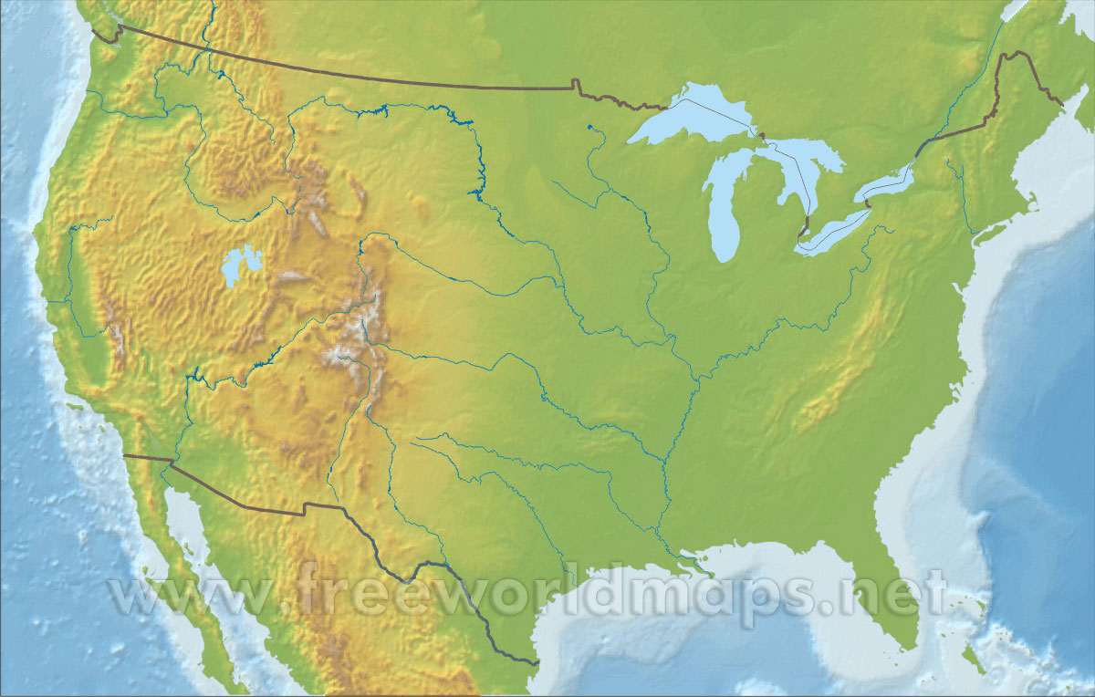

Death Valley

Great Plains

Atlantic Coastal Plains

Gulf of Mexico

Great Basin

Great Lakes

Continental Divide= Rocky Mountains

St. Lawrence River